Ronin ($RON) Report
Jordan Combs, Justin Fieldman, and Richie E. Dorjgurkhem

Introduction

GameFi is one of the fastest growing markets within the Blockchain industry. The market represents a sector that combines elements of gaming, finance, and blockchain technology that has gained attraction worldwide. Despite periods of sluggish growth, bearish markets, and a chillish crypto winter, there is still a consensus that the future outlook for GameFi is optimistic. For instance, it saw an 84% increase in investments in 2022, where projects received $5.4 billion at year’s end, compared to $2.4 billion in 2021.

GameFi represents one of the biggest sectors in the blockchain industry. Although Web3 gaming may be behind in gaming experience compared to Web2, they are already changing it. With its potential and explosive growth, we should have a hand in this opportunity. By investing in Ronin, we get that exposure.

General Background on Protocol

Ronin is an EVM blockchain specifically intended for gaming. It was launched by Sky Mavis, creator of Axie Infinity. Currently, Axie Infinity is the only game that is online, but four game studios have partnered with Sky Mavis in March 2023 to utilize their blockchain for their titles.

Macro Factors Impacting Protocol

- Macroeconomics
- Crypto Regulation
- Gaming industry

General Auditing Background for Protocol

As of Apr 28, 2023, Ronin has the following audits done:

Ronin Bridge
- Verichains
- CertiK

Ronin DPoS
- CertiK

Ronin Wallet
- Verichains

Specific on What Protocol Does

Sky Mavis‘s idea is to have a sidechain that allows developers to create games with player-owned economies. Ronin does this with near-instant transactions (~3s) and affordable fees that enable millions of in-game transactions to occur seamlessly, making it the leading choice for Web3 games.

Why the Protocol Offering Matters to Consumers

Ronin, as an EVM (Ethereum Virtual Machine) blockchain specifically designed for gaming, has several important aspects that matter to consumers.

- Scalability and Performance: Ronin has demonstrated its ability to scale a single game, such as Axie Infinity, to accommodate millions of daily active users. This means that consumers can expect a seamless gaming experience with near-instant transactions and negligible fees. The platform's optimization for gaming ensures minimal transaction delays and a smooth in-game economy.

- Proven Track Record: Ronin has processed over $4 billion in NFT (Non-Fungible Token) volumes and accounted for 15% of all NFT trading volume in 2021. It is the home of all Axie Infinity assets, which is the leading NFT project by adoption and all-time volume. Ronin's track record establishes it as a reliable and trusted platform for gamers and NFT enthusiasts.

- Backed by Sky Mavis: Sky Mavis, the creator of Axie Infinity, is the driving force behind Ronin. Their experience in building and scaling Axie Infinity has given them valuable insights into product development, community building, and go-to-market strategies. This expertise can be leveraged by partners deploying on the Ronin network, potentially leading to more innovative and successful games on the platform.

- Security and Trust: Ronin's security measures have been refined through their experience with security threats, such as the Ronin Validator Breach. Sky Mavis has implemented rigorous internal security measures and undergone comprehensive code reviews and optimizations. Consumers can have confidence in the platform's security, knowing it has been battle-tested and hardened against potential attacks.

- Consensus Mechanisms: Ronin initially used Proof of Authority (PoA) consensus, which offers faster transaction speeds, lower fees, and reduced energy consumption compared to other mechanisms like Proof of Work (PoW). While PoA has been criticized for its centralized nature, Ronin has increased its decentralization by integrating Delegated Proof of Stake (DPoS). DPoS allows token holders to become validators, fostering a more decentralized network while retaining the benefits of PoA.

Protocol Versus Competitors Chart

Comparable Financials:
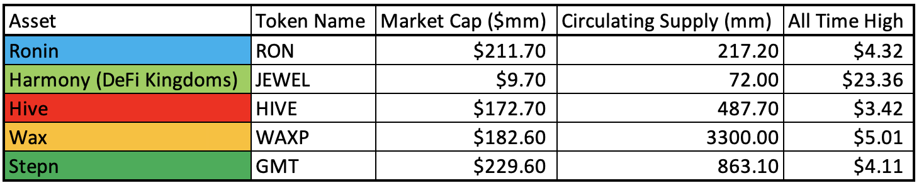

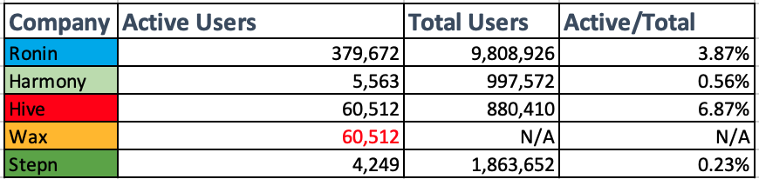
* Based on the most popular games on each blockchain

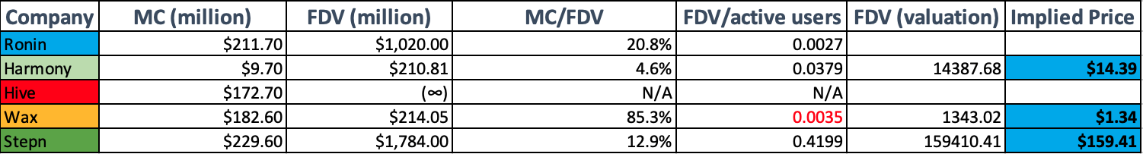

Finding Implied Price:
0.0035 (ratio) * 379672 (active users) = $1.34 per token

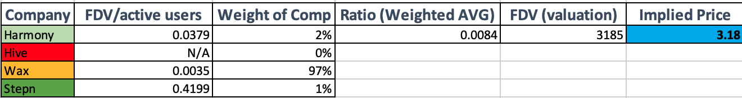

Weighted AVG

[0.0379*2%] + [0.0035*97%] + [0.4199*1%] = 0.0084 (Weighted AVG ratio)
0.0084 * 379672 (active users) = 3185M
3185M / 1000M (max supply of tokens) = $3.18 per token

Protocol Go To Market Strategy Versus Competitors

One of the key objectives of the Ronin Chain's go-to-market strategy is to address the scalability challenges faced by the Ethereum network, allowing Axie Infinity to handle a larger number of users and transactions with reduced costs and faster transaction times.
Unique Value Proposition of the $RON Chain:
- Seamless Integration: The Ronin Chain is purpose-built for the use of games within the ecosystem, such as Axie Infinity, allowing for a seamless integration with the game's smart contracts and ecosystem. This close integration ensures compatibility and optimized performance for $RON players.
- Community and User Base: Axie Infinity has gained significant popularity and a strong community of players and collectors. Sky Mavis has leveraged this existing user base and community to drive adoption and usage of the Ronin Chain.
- Scalability and Cost-Effectiveness: The Ronin Chain aims to provide high scalability. For example, it enables Axie Infinity to handle a large number of players and transactions without congesting the Ethereum network. Additionally, the use of the Ronin Chain can reduce transaction fees and gas costs, making it more cost-effective for players.
- Ecosystem Support: Sky Mavis actively collaborates with developers, partners, and projects within the ecosystem to drive adoption of the Ronin Chain. This includes supporting third-party developers in building on top of the Ronin Chain and fostering an ecosystem of DeFi Gaming.

How Token Extracts Value

The $RON token in the Axie Infinity ecosystem extracts value through governance participation, staking rewards, utility within the game, and liquidity through trading on cryptocurrency exchanges. Token holders can influence decisions, earn rewards for staking, use tokens in gameplay and economy, and trade them for potential financial gains.

Tokenomics/Vesting Schedule

$RON is the ecosystem token of the Ronin blockchain in Axie Infinity. It serves various purposes such as facilitating transactions, enabling DeFi features, and offering utility through staking for rewards. Validators participate in block validation by staking $RON and receive newly issued tokens as rewards. The token distribution consists of rewards (25%), community incentives (30%), Sky Mavis (30%), and the ecosystem fund (15%). The total supply of $RON is capped at 1,000,000,000, and tokens are unlocked gradually over a 108-month (9-year) period. The unlock schedule shows the quarterly distribution of unlocked tokens, with the initial unlock occurring at Month 0.

Road Map

Goal is to gradually decentralize Sky Mavis products. Retain Proof of Authority but have integrated Delegated Proof of Stake for delegation and validator selection. Ronin will increase the accessibility of its games and the ease of creation for developers.

Conclusion

​​In conclusion, GameFi, particularly the Ronin protocol, is a rapidly growing sector within the blockchain industry. Ronin offers scalable, secure, and optimized blockchain infrastructure for gaming, backed by the successful track record of Axie Infinity. The $RON token provides value through governance participation, staking rewards, and utility within the ecosystem. With a strong go-to-market strategy, Ronin aims to address Ethereum's scalability challenges and foster a vibrant gaming community. Overall, Ronin presents an enticing opportunity in the evolving landscape of blockchain gaming.

Fund Recommendation

0.3 ETH in Ronin and stake
- Possibly become delegators for validators (Google, Nansen)

